Experiment: 7
Analog Beamforming Analysis Using MATLAB
Objective – 1
Analyze Beamforming Gain (dB)
Code:
clc;
clear;
close all;
antennas = [2 4 8 16 32]; % Number of Antenna Elements
gain = 10*log10(antennas); % Beamforming Gain (dB)
figure
bar(antennas, gain)
grid on
xlabel('Number of Antenna Elements')
ylabel('Beamforming Gain (dB)')
title('Beamforming Gain for Different Antenna Array Sizes')
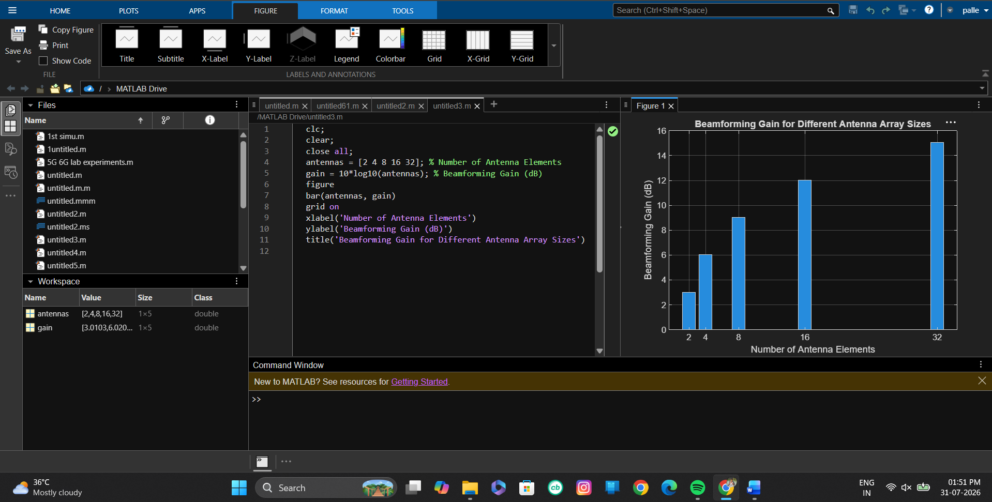
Objective – 2
Compare Beam Width (Degrees)
Code:
clc;
clear;
close all;
antennas = [2 4 8 16 32]; % Number of Antenna Elements
beamwidth = [90 45 22.5 11.25 5.625]; % Beam Width (degrees)
figure
plot(antennas, beamwidth,'o-','LineWidth',2)
grid on
xlabel('Number of Antenna Elements')
ylabel('Beam Width (Degrees)')
title('Beam Width for Different Antenna Array Sizes')

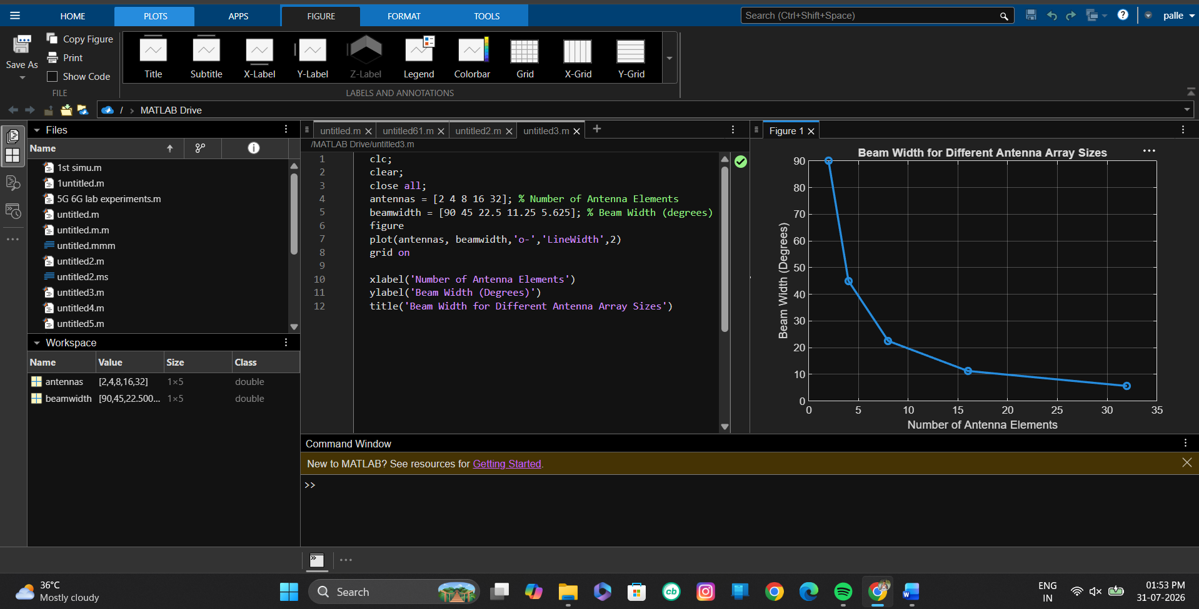

Objective – 3
Analyze Main Lobe Direction (Degrees)
Code:
clc;
clear;
close all;
theta = [-60 -30 0 30 60]; % Main Lobe Direction (degrees)
gain = [1 1 1 1 1]; % Constant normalized gain
figure
polarplot(deg2rad(theta), gain, 'o', 'LineWidth', 2)
title('Main Lobe Direction in Analog Beamforming')
